**How to connect to Google in China**

Method 1: use the provided VPN service

Recommend: Express VPN (English/French website, credit card supported, a little expensive)

Website: <https://www.expressvpn.com>

Unfortunately, this website is also blocked by the Great Fire Wall.

Therefore, you should get the shadowsocks.exe first. The file is attached in this repository.

1. Extract the zip file and open the .exe file.
2. There will be a little airplane at the lower right corner of the desktop. Right click the icon, choose servers->edit servers.

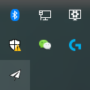

1. Choose “Add”, then input the Server IP and Server Port as it is shown in the figure below. The Password is:***guest***. Let the Encryption and Proxy Port as the default setting, click OK. (This IP address is the server I’ve rent).

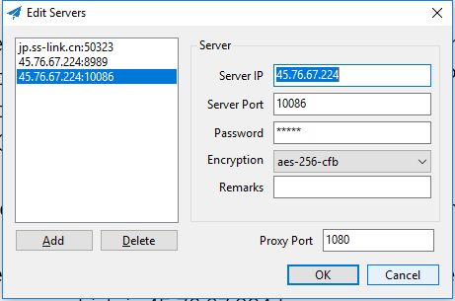

1. Remember to choose the right server after setting the server. Then click the Enable System Proxy. There are two Mode: PAC and Global.

PAC: if the browser is requesting a site which is not blocked, the request will not be sent to the proxy server which is 45.76.67.224 here.

Global: all the http request will be sent to the proxy server. In short, if you want to visit the unblocked websites and the blocked websites at the same time, choose the PAC mode.

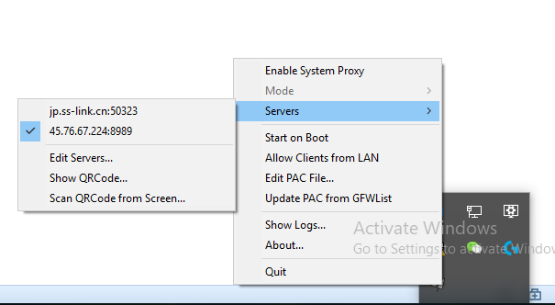

1. If everything goes well, you can surf all the website through your browser now, then you can visit the site of ExpressVPN or some other VPNs and get your own VPN. In their website, they have the full guide of how to use their VPN.

Attention: due to the huge package lost rate between the computers in China and the 45.76.67.224 sever which is in USA, the quality of service is not good enough. So if you are sure all the settings are right, and you still cannot connect to google or your browser shows “502 bad gateway”, try to reboot the shadowsocks or re-enable the system proxy.

Method 2: rent a server and install script of shadowsocks

//not finished. It is a little complicated, so use the method 1 at the moment.

Reference: <https://www.jianshu.com/p/1c82ee1293a4?open_source=weibo_search>

//2018.05.03 The reference website is banned like one month ago, so I’m not gonna to translate it…

Still, vive la liberté.

1. Get shadowsocks.exe. The method is the same as it is in METHOD 1.

#### Register Vultr. Open link: https://www.vultr.com, click Create Account.

#### https://upload-images.jianshu.io/upload_images/3883542-a393d98c540c2923.jpg?imageMogr2/auto-orient/

#### Charge the Vultr. Vultr provides 4 ways of charging. The Credit Card and Paypal are supported.

#### https://upload-images.jianshu.io/upload_images/3883542-2b240230b4a8c30a.jpg?imageMogr2/auto-orient/strip%7CimageView2/2/w/700

#### Create the VPS. Choose the “servers” in the left side menu, then click the “+” on the right side.

#### https://upload-images.jianshu.io/upload_images/3883542-ee1d05af94ce2141.jpg?imageMogr2/auto-orient/strip%7CimageView2/2/w/700

#### Choose the VPS location. Attention: the Japan and Singapore servers are blocked, so don’t choose the servers in these two countries.

1. Choose the OS and price.

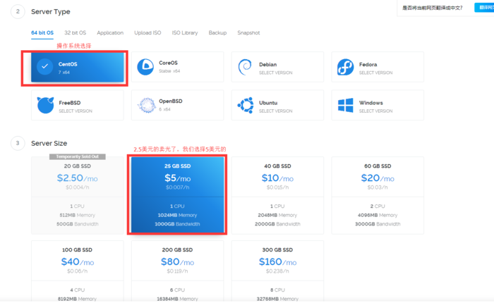

https://upload-images.jianshu.io/upload_images/3883542-32fe2a620e144c34.jpg?imageMogr2/auto-orient/strip%7CimageView2/2/w/700